11th March 2022

Dear Parents and Carers

It has come to my attention that there are some adults who find it acceptable to use offensive language whilst waiting in the playground.

I must remind you that this is certainly not acceptable behaviour, especially as there are often younger siblings waiting in the playground, along with Junior School pupils at times. In addition, it has been mentioned that this behaviour is occurring very close to the Nursery building and adjacent to the Conference Room, which is used for groups of children to work undisturbed.

I am sure you will agree that this is unacceptable and, should I receive further complaints, then the adults involved may be prevented from entering the school site.

Yours sincerely
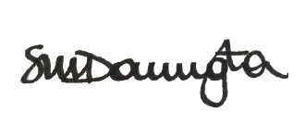
Mrs Sandra Dorrington
Headteacher

